14-15学年上学期八年级英语月考试卷
（ 120分 ，考试时间90分钟 ）
一、听力（20分，每小题1分）
I. 听下面5个句子，选择与你所听到的内容相符的图片。听完每个句子后，你都将有10秒钟的时间回答有关小题和阅读下一小题。每个句子读一遍。
1. ( )
A.  B. 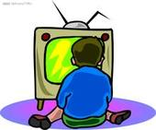 C. 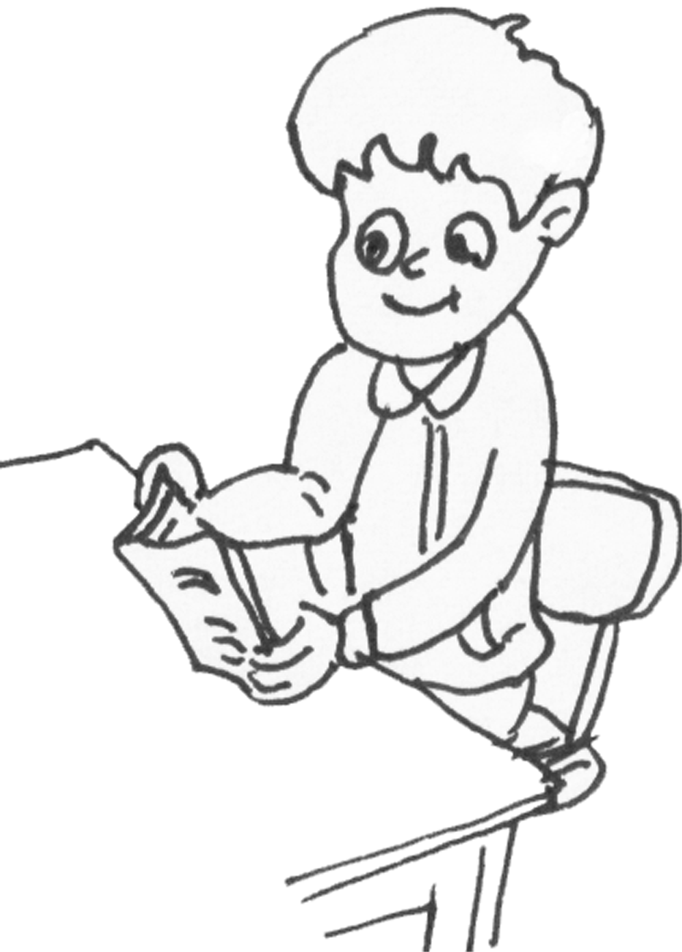
2. ( )
A.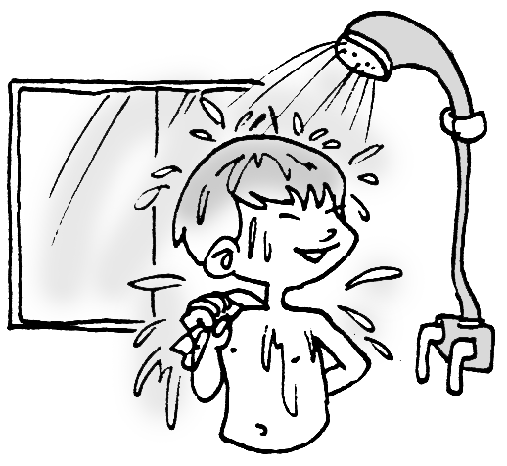 B.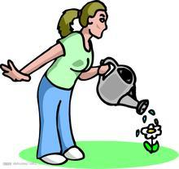 C. 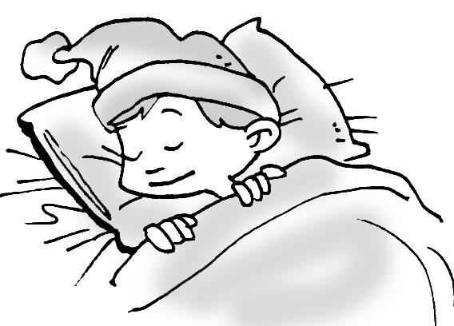
3. ( )
A.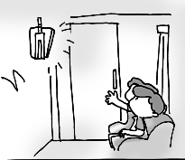 B.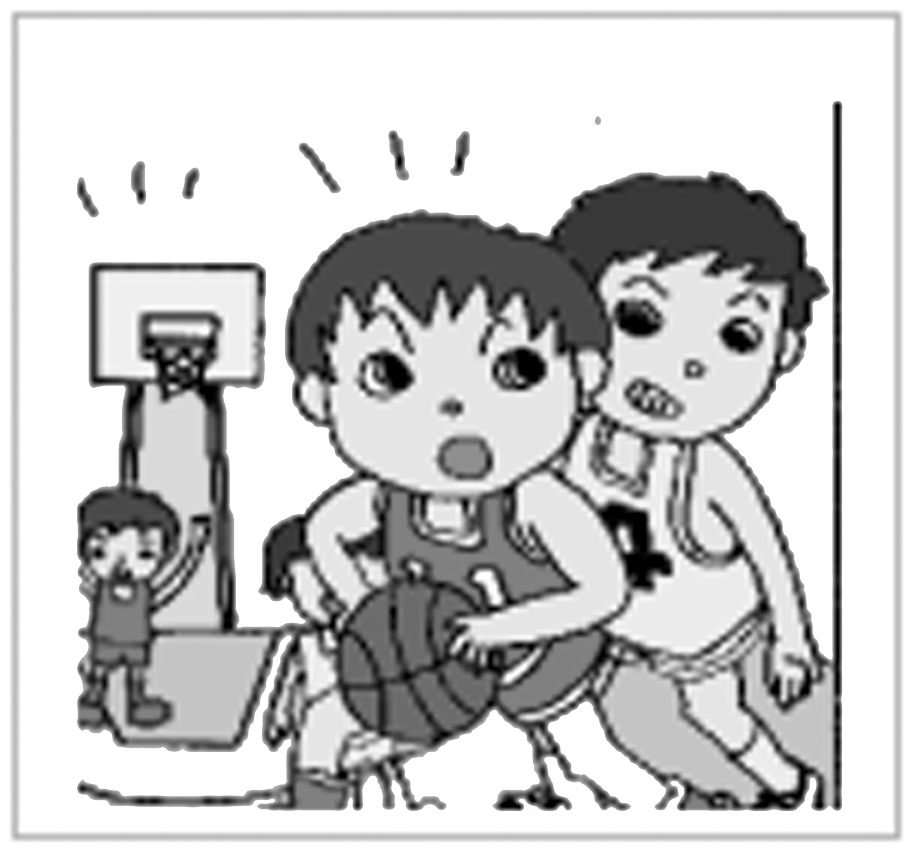 C.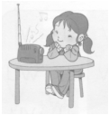
4. ( )
A. 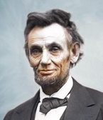 B. 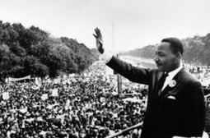 C. 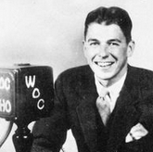

5. ( )
A.  B.  C. 

II. 听下面5段小对话。每段对话后有一个小题，从题中所给的A、B、C三个选项中选出最佳选项。听完每段对话后，你都将有10秒钟的时间回答有关小题和阅读下一小题。每段对话读一遍。
( )6. What kind of book was David reading last night?
A. A book about robots. B. A science fiction.
C. A book about the UFO.
( )7. What was James doing when Gina called him?
A. He was playing outside. B. He was cleaning his bike.
C. He was watering flowers.
( )8. Why was Susan tired?
A. Because she went to bed late. B. Because she repaired the radio.
C. Because she was looking for a radio.
( )9. How long did it take Anna to finish her homework?
A. Only half an hour. B. About an hour.
C. About one and a half hours.
( )10. What’s Maria’s favorite program?
A. Space World. B. Animal World. C. Alien World.
III. 听下面2段长对话。每段对话后有几个小题，从题中所给的A、B、C三个选项中选出最佳选项。听每段对话前你都将有30秒钟的时间阅读各小题。每段对话读两遍。
听第一段对话，回答第11—12小题。
( ) 11. What was the man doing at 7:00 last night?
A. He was reading a book. B. He was seeing a film.
C. He was doing his homework.
( ) 12. When did the man get to the cinema?
A. At 6:00. B. At 6:30. C. At 7:00.
听第二段对话，回答第13—15小题
( ) 13. Why did the woman look tired?
A. Because she didn’t have a good sleep.
B. Because she cleaned her window all night.
C. Because she saw a tiger.
( ) 14. What was on the window according to the woman?
A. A picture. B. A cat. C. A UFO.
( ) 15. Does the man believe what the woman said?
A. Yes, he does. B. No, he doesn’t. C. We don’t know.
V. 请听下面一段短文，根据短文内容完成表格，每个空格不超过3个单词。听短文前你将有 50秒钟的时间阅读表格内容。短文读两遍。
Name | What he/ she was doing when the lights went out
Mrs. Brown | 16.
Mr. Brown | 17.
Maria’s parents | 18.
Maria | Reading a book.
An old woman | 19.
A young woman | 20.

二．单项选择（共15分，每小题1分）
( )21. Bob used to ___in the countryside . But now he is used to __ in the big city .
A . live live B live; living C. living living D living , live
( )22. Tom’s mother____ in the kitchen when the bell____.
A. cooks; ringed B. cooks; was ringing
C. was cooking; rang D. was cooking; was ringing
( )23. If it ____tomorrow, I____ hiking in the mountains.
A. will rain; don’t go B. doesn’t rain; will go
C .won’t rain; don’t go D. rains; will go
( )24 . The music is too loud. Would you mind_____?
A .turning it on B .turning on it C .turning it down D. turning down it
( )25. Mother told me ____and I stopped_____.
A. not to smoke; smoking B. not smoke; smoking
C. not to smoke; to smoke D. to smoke; to smoke
( )26. —Bob is ____ late for school.
—Neither am I .
A. always B. often C. ever D. never
( )27. He ___ to turn off the light and __ his bag in his classroom yesterday.
A. forgot, forgot B. left, left C. forgot, left D. left, forgot
( )28.--What kind of pets do you want to get ?What about a cat?
--I don’t like cats. They are not_______.
A .friendly enough B. enough friendly C. friend enough D. enough friend
( )29.--I want to buy the CD, but I have _____ money.
—Why not _____some from your parents?
A. no; lend B. no; borrow C.much lend D .much borrow
( )30. More than three _______ people are at the party.
A. thousands B. thousand C. thousands of D. thousand of
( )31.The environment is becoming worse and worse. I hope there will be___cars
and___pollution.
A. fewer; fewer B. less; less C. fewer; less D. less; fewer
( )32.Yesterday my dad spent all his free time games_____ us.
A. play in B. played to C. plays with D. playing with
( )33.It’s not easy for some people___ a good job in big cities.
A. find B. to find C. finding D. found
( )34.---Why not hang out and go shopping with us, Li Yun?
--- _________, but I will help Mom with housework, she is very busy.
A. All right B. Let’s go C. I’d love to D. Yes, please.
( )35._____Daming’s help , the problems are solved successfully .
A .As for B. Thanks for C. Thanks to D. According to
三、 完型填空.根据短文内容，选择最佳答案完整短文。（每小题1分，共10分）
One Friday night, a poor young man stood at the train station. He played his violin and many people put 36.________ into the hat in front of him.
The next day, the young man came to the station 37.________. But this time he took out a large piece of paper 38.________ some words on it. It said，“Last night a lady 39.________ Mrs Sang put an important thing into my hat 40.________. Please come for it. ”
After about an hour, a middle-aged woman ran to the young man in a hurry and said, “You do come here. I know that you're a(n) 41.________ man and will certainly come here.” They had a talk and the young man made sure she was the owner. Then he took out a lottery ticket (彩票) and 42.________it to the woman. Her husband bought a lottery ticket every day. Yesterday when she knew the lottery ticket he bought won, she was very 43.________. The prize of the lottery ticket was$500，000. When she walked past the young man, she took out $50 and put it in the hat. 44.________， the lottery ticket was also thrown in.
Later, someone asked the young man, “You play the violin every day to make money. Why didn't you just take the prize of the lottery ticket for yourself？” The young man said，“Although I don't have much money, I live happily. But if I 45.________ honesty, I won't be happy forever.”
( )36. A．money B．tickets C．paper
( )37. A．instead B．differently C．again
( )38. A．for B．with C．over
( )39. A．introduced B．spelled C．named
( )40. A．by mistake B．for mistake C．on mistake
( )41. A．crazy B．cool C．honest
( )41. A．gave B．lent C．offered
( )43. A．surprising B．happy C．exciting
( )44. A．But B．However C．Therefore
( )45. A．have B．win C．lose
四、阅读理解： （共20分，每小题1分）
A
Maybe you have seen this in schools: some students are studying nearly all the time but they just pass their exams, while some others may spend much less time on their books but do much better in exams. How could this happen? People used to think that hard work is the only way to success. But now they have understood that smart work can make them succeed, too.
Hard workers don't mind working for long hours, while smart workers always think of several different answers to these questions, “Why should I suffer this?” “Isn't there a better way to do this?” Thanks to these people, we can use computers instead of the abacus now. Progress in every field is the direct result of “try to find a better way” by smart workers.
There was a large soap factory in Japan. Once it received an unusual letter from someone who complained that there was no soap in the soapbox he bought.
How could empty soapboxes go out of the factory? The engineers checked the producing and packing. The producing was fine, but in about one in ten thousand cases, the packing machine (机器) let an empty soapbox go. There was no need to spend a lot of money repairing the machine for such a small problem. The engineer soon worked out a solution; he put a huge Xray machine and two large computers to find out the empty soapboxes. After teaching the workers how to use it, he sat down in his seat, exhausted.
“Sir, we could have solved the problems in a much simpler and cheaper way，” a worker said.
“Really? How？”
“We can put a huge fan near the packing machine. The wind coming from the fan will blow away the empty boxes, leaving the other boxes with soap.”
See, this is smart work. In order to succeed, we should not only work hard like the engineer, but also think smart like this worker.
( )46. Some students spend less time on schoolwork but do better in exams ________.
A．because of their hard work
B．because of different education
C．because they try to find a better way
D．because they study for a much longer time
( )47. Someone wrote to the soap factory and complained that ________.
A．the soapbox he bought was empty B．their soap was too expensive
C．the soap he bought was terrible D．their service was very bad
( )48. The soap factory could only ________ near the packing machine to solve the problems in a much simpler and cheaper way.
A．set some soapboxes B．set an Xray machine
C．put two large computers D．put a huge fan
( )49. The phrase “blow away” in the passage means “________”.
A．停止 B．远离 C．吹走 D．逃脱
( )50. The article mainly tells us we should ________ in order to succeed.
A．work hard for long hours and study all the time
B．work hard like the engineer and think smart like the worker
C．spend much less time on our schoolwork than before
D．spend enough money repairing the machine for any problem

B
It was the first day of third grade. Samuel sat in the classroom and he already knew most of the students in his class.
In the back of the classroom was a face that Samuel didn’t know. There sat a boy with dark hair and glasses.
Mr. Dale called the students by their names. “Ho Ming?” said Mr. Dale. The boy in the back put up his hand.
Ho Ming was from China. His family moved to the United States during the summer. Ho Ming seemed shy.
Samuel tried to talk to Ho Ming, but he only smiled. Finally, Samuel understood the problem. This country was new to Ho Ming. Maybe the language was new to him too.
That night Samuel asked his mom for help. Together they looked up some Chinese words on the Internet. Mom helped Samuel pronounce (发音) the words over and over again.
The next morning Samuel went to talk to Ho Ming. Then he stopped. He was afraid he would say something wrong. He was afraid he would sound silly. “This must be how Ho Ming feels,” he thought.
“Hello,” he said, using the Chinese words he learned. “I am your friend.”
Ho Ming looked surprised. He answered Samuel in Chinese. Samuel had no idea what Ho Ming was saying.
“My English is not too good yet,” explained Ho Ming.
“Neither is my Chinese,” said Samuel.
“I will teach you,” offered Ho Ming.
“And I will teach you,” said Samuel.
Samuel took a ball out of his bag. “Want to play?” he asked.
Ho Ming only smiled. Sometimes words are not even necessary.
根据材料内容选择最佳答案。
( )51. What did Samuel and Ho Ming have in common?
A. They both wore glasses. B. They were in the same class.
C. They both went to a new school. D. They were from the same country.
( )52. What is the main idea of Paragraph 6?
A. Samuel learned Chinese words. B. Samuel liked studying with his mom.
C. Samuel liked studying on the Internet. D. Samuel was good at learning languages.
( )53. According to Paragraph 7, we can know that Samuel felt _____ before talking to Ho Ming.
A. nervous B. sad C. excited D. surprised
( )54. At the end of this story, Samuel and Ho Ming will probably _____.
A. study together B. go to the library C. visit their friends D. play with the ball
( )55. Which of the following is TRUE according to the passage?
A. Samuel spoke Chinese very well.
B. Ho Ming sat in the back of the classroom.
C. Ho Ming moved to the United States last winter.
D. Samuel learned Chinese words with the help of his teacher.
C

Tammy came home from school with a note (便条) from her teacher, Ms. Jones. The note said, “Tammy is having trouble seeing the blackboard. Maybe she needs to go to an eye doctor.”
After Mom read the note, she asked Tammy, “How long did you have trouble seeing the blackboard?”
“About a month.”
“I will call Dr. Gray and you’re going to see her tomorrow after school.”
Tammy went to her room and began to worry. That night Tammy did not sleep.
The next day after school, Tammy went to Dr. Gray’s office with her mom. When Tammy went in to see the doctor, she was so nervous (紧张的). The doctor told her and her mom that Tammy was having trouble seeing things from far away. She told Tammy that she would need to choose a pair of glasses to help her see well. Tammy looked worried.
“What’s the matter?” asked Dr. Gray.
“I don’t want to wear glasses! All the girls are going to laugh at (嘲笑) me.”
“Why aren’t you laughing at me? I’m wearing glasses.”
“You look so beautiful in yours.”
“Then let’s choose some glasses that look almost like mine.”
Tammy and Dr. Gray found a pair of brown and black glasses. Tammy wore the glasses and read from far away. “Everything looks so clear!” said Tammy. “I really like my new glasses.”
Tammy went to school the next day and wore her glasses to read the blackboard. “Tammy, your glasses are so cool!” said the girls. Tammy felt so much better.
根据材料内容选择最佳答案。
( )56. Why did Ms. Jones ask Tammy to take a note home?
- Because Tammy couldn’t see well.
- B. Because Tammy had a stomachache.
C. Because Tammy didn’t do her homework.
D. Because Tammy got hurt when playing volleyball.
( )57. How did Tammy feel when she knew she had to go to the doctor?
A. Surprised. B. Bored. C. Worried. D. Happy.
( )58. What color were Tammy’s glasses?
A. Blue and white. B. Brown and white.
C. Black and blue. D. Brown and black.
( )59. What can we learn from the passage?
A. Tammy didn’t like doing homework.
B. Tammy cared how well she looked in glasses.
C. Tammy had trouble getting along with her classmates.
D. Tammy’s teacher knew Tammy’s problem from other girls.
( )60. The writer wrote the passage to tell us ______.
A. how to choose glasses
B. never to laugh at others
C. it is necessary to help those in trouble
D. things aren’t always as bad as we expect

D
The Earth has warmed by about half a degree(0.5℃)over the last 100 years. It could be getting warmer on its own，but many scientists think that people are making the Earth warmer by making a greenhouse effect(温室效应)．The greenhouse effect is important. Without it, the Earth would not be warm enough for us to live on. But just a little warmer than it is now could cause(引起)problems for humans，plants and animals.
Many of the things we do every day can change the Earth's temperature by sending greenhouse gases(废气) into the air. We send greenhouse gases into the air when we watch TV, turn on lights, dry hair, play video games，wash or dry our clothes or drive cars. The rubbish(waste) from factories and homes also produces greenhouse gases.
Even a small change in temperature can affect(影响) our weather. This can cause changes in the sea levels, the air, flooding, and our fresh water.
The change in the temperature can also cause changes in the living places for animals and plants, endangering many animals.
Global warming(全球变暖) is a big problem, and every little bit we do can help. We can save electricity. We can save energy in other ways such as by taking buses or walking rather than driving cars. We can recycle to reduce the rubbish and save natural resources such as trees, oil and metals. We can buy products that don't do bad to the environment and we can turn to solar energy. Remember the little bit that you do will bring a better world.
( )61. Which of the following does not send greenhouse gases into the air?
A．Turning on a light. B．Walking to school.
C．Driving a car. D．Watching TV.
( )62. In this passage, the scientists are mainly trying to make the readers realize ________.
A．the earth could be getting warmer by itself
B．the earth is getting warmer in 100 years
C．the greenhouse effect is important
D．humans are making the earth warmer
( )63. Without the greenhouse effect，we would ________.
A．not be able to live B．be safer
C．have a cleaner earth D．have a better world
( )64. The writer gives us advice on how to save energy in________.
A．Paragraph 2 B．Paragraph 3
C．Paragraph 4 D．Paragraph 5
( )65. Global warming is a big problem but ________.
A．we can't do anything to help B．we don't need to do anything
C．we can do something to help D．we can do something to stop it
五、阅读短文，从方框中选择恰当的词并用其适当形式填空，使短文通顺、意思完整，每词限用一次，其中有两个词是多余的。（10分）
week, he, what, idea, why, refuse, dog, daughter, start, do, hope, read
Jennifer and her sister Katie learned in Sunday School how they should care about others. This gave them a great idea! “Let’s (66)________ a new club at school. We can call it THE CARE CLUB!” said Katie. “CARE means Caring and Respecting (尊重) Everybody.” Jennifer agreed it was a wonderful (67)________. Every night they planned (68)________ they would do the next day to show love to others.
One day they helped a boy with (69)________ homework after school. Another day they stayed after school to help a little girl learn to (70)________. On the weekend they walked a neighbor’s (71)________ and even gave the dog a good shower. Katie and Jennifer’s parents understand their (72)________ very well. They also love helping others and they are having so much fun (73)________ it.
Later, the other kids at school (74)________ to join the club. So Katie and Jennifer opened the club up to new members (成员). Every new member had to promise to show love to others. They had (75)________ meetings and planned who they would help and how they would do it. Everyone pitched in (出) some money each week so they could buy flowers or cards for sick people to cheer them up.

- 补全对话(5小题，每小题2分，共10分)
情景交际(每小题2分，共10分)
根据对话内容，在空白处填入恰当的句子，使对话完整、通顺。
A: Tom, I need your help.
B: OK, Mom. But please wait for a minute.
A: (76)_______________________?
B: I’m playing computer games.
A: You shouldn’t play them any more. Come here quickly.
B: I’m coming, Mom. What can I do?
A: Could you please do the dishes?
B: Sure, Mom. (77)_______________________?
A: They are on the table in the kitchen.
B: What do I have to do after doing the dishes?
A: (78)_______________________? I was too busy to sweep the floor this morning.
B: No problem. Anything else?
A: Nothing. You can watch TV after doing these things.
B: (79)_______________________?
A: You can watch TV for an hour.
B: (80)_______________________?
A: I’m going to have a meeting.
B: OK, Mom.
七．书面表达(15分)
假如你是珍妮(Jenny)，你从朋友迈克(Mike)的来信中了解到他的烦恼。请你根据下面的提示用英语给迈克写一封回信，告诉他该怎么做。
提示：1. 迈克和弟弟相处得不好，有时候还打架；
2. 迈克弟弟总是播放CD声音很大，影响迈克学习；
3. 迈克弟弟总是私自拿迈克的学习用具且不归还。
要求：1. 针对每一件烦心事提出相应的建议；
2. 80词左右。信的格式、开头和结尾已给出，不计入总词数。
Dear Mike,
How are you? From your letter I see that you’re having problems. Here is some advice for you.
_________________________________________________________________________________________________________________________________________________________________________________________________________________________________________ _

I hope my advice can help you.
Yours,
Jenny

